Design Principles - Dependency Inversion Principle (DIP)
# Source: AI Source: Provided by: [Data Path: Persons Table -> ID Column: 1, Name_En Column: Motasem Essam] -> From: [ChatGPT] on [1/23/2026]
The Dependency Inversion Principle states that high-level modules should not depend on low-level modules; both should depend on abstractions (interfaces or abstract classes).
👉 Think of it like using a standard power plug: the device (high-level) doesn’t care which specific socket (low-level) it’s plugged into, as long as the interface works.

🔑 Key Points
# Source: AI Source: Provided by: [Data Path: Persons Table -> ID Column: 1, Name_En Column: Motasem Essam] -> From: [ChatGPT] on [1/23/2026]
• High-level modules depend on abstractions, not concrete implementations
• Low-level modules also depend on interfaces
• Reduces tight coupling between modules
• Makes code flexible, maintainable, and testable

❌ Bad Example
# Source: AI Source: Provided by: [Data Path: Persons Table -> ID Column: 1, Name_En Column: Motasem Essam] -> From: [ChatGPT] on [1/23/2026]
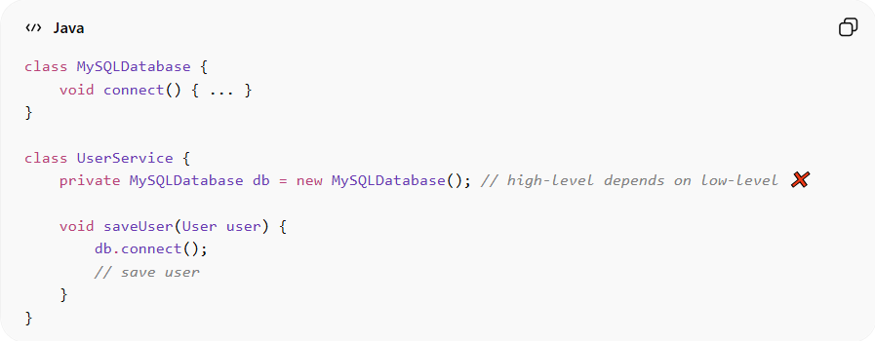
class MySQLDatabase {
void connect() { ... }
}

class UserService {
private MySQLDatabase db = new MySQLDatabase(); // high-level depends on low-level ❌

void saveUser(User user) {
db.connect();
// save user
}
}
Problems:
• UserService is tightly coupled to MySQLDatabase
• Hard to replace database or test UserService
• Violates DIP → reduces flexibility and maintainability

✅ Good Example
# Source: AI Source: Provided by: [Data Path: Persons Table -> ID Column: 1, Name_En Column: Motasem Essam] -> From: [ChatGPT] on [1/23/2026]
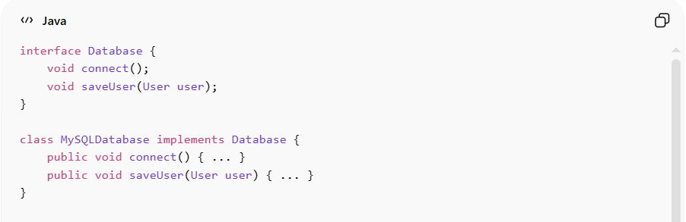
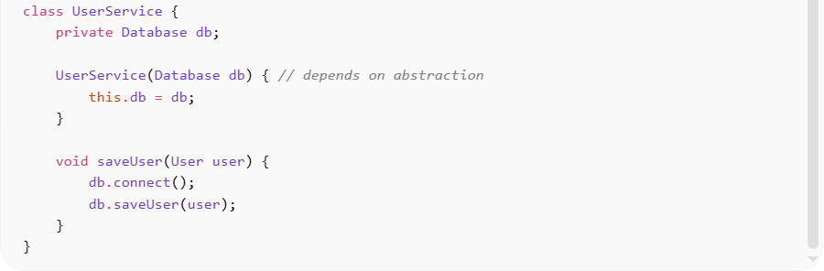
interface Database {
void connect();
void saveUser(User user);
}

class MySQLDatabase implements Database {
public void connect() { ... }
public void saveUser(User user) { ... }
}

class UserService {
private Database db;

UserService(Database db) { // depends on abstraction
this.db = db;
}

void saveUser(User user) {
db.connect();
db.saveUser(user);
}
}
Benefits:
• UserService depends on Database interface, not concrete MySQLDatabase
• Easy to swap implementations (e.g., PostgreSQLDatabase, MockDatabase)
• Supports unit testing, flexibility, and modularity
• Reduces tight coupling and improves maintainability

⚡ When to Apply
# Source: AI Source: Provided by: [Data Path: Persons Table -> ID Column: 1, Name_En Column: Motasem Essam] -> From: [ChatGPT] on [1/23/2026]
• Always — especially in enterprise and layered architectures
• Works best with Dependency Injection frameworks
• Combine with SRP, OCP, and IoC for clean, extensible code
• Useful in service classes, APIs, and reusable libraries

